WEEK 1 : COGNIZANT FSE HANDS-ON EXERCISES

Exercise 1: Implementing the Singleton Pattern
Logger.java
package singleton;
public class Logger
{
private static Logger instance;
private Logger()
{
System.out.println("Logger initialized...");
}
public static Logger getInstance()
{
if (instance == null)
{
instance = new Logger();
}
return instance;
}
public void log(String message)
{
System.out.println("[LOG] " + message);
}
}
LoggerTest.java
package singleton;
public class LoggerTest
{
public static void main(String[] args)
{
Logger logger1 = Logger.getInstance();
Logger logger2 = Logger.getInstance();
logger1.log("First log message");
logger2.log("Second log message");
if (logger1 == logger2)
{
System.out.println("Both logger instances are the same (Singleton works!)");
} else
{
System.out.println("Different logger instances (Singleton failed!)");
}
}
}
Output
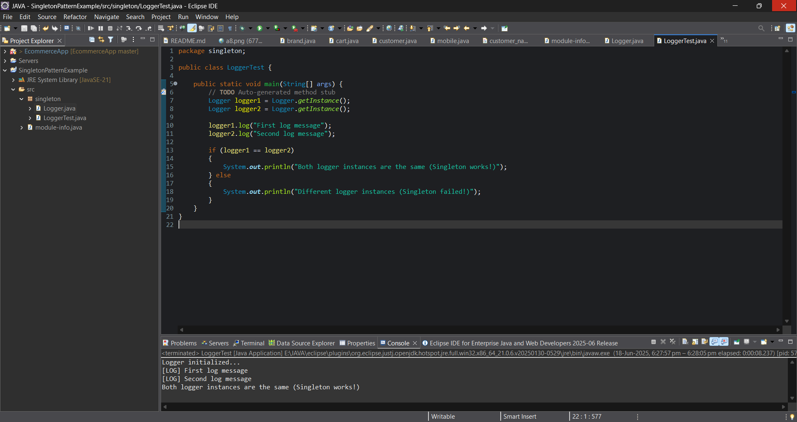

Exercise 2: Implementing the Factory Method Pattern

#Creating Interface
Document
public interface Document {
void open();
}

#Creating Concrete Document Classes
WordDocument.java
public class WordDocument implements Document
{
@Override
public void open()
{
System.out.println("Opening a Word document.");
}
}

PdfDocument.java
public class PdfDocument implements Document
{
@Override
public void open()
{
System.out.println("Opening a PDF document.");
}
}

ExcelDocument.java
public class ExcelDocument implements Document
{
@Override
public void open()
{
System.out.println("Opening an Excel document.");
}
}

#Creating Abstract Factory Class
DocumentFactory.java
public abstract class DocumentFactory
{
public abstract Document createDocument();
}

#Creating Concrete Factories
WordFactory.java
public class WordFactory extends DocumentFactory
{
@Override
public Document createDocument()
{
return new WordDocument();
}
}

PdfFactory.java
public class PdfFactory extends DocumentFactory {
@Override
public Document createDocument() {
return new PdfDocument();
}
}

ExcelFactory.java
public class ExcelFactory extends DocumentFactory
{
@Override
public Document createDocument()
{
return new ExcelDocument();
}
}

#Creating Test Class
Main.java
public class Main {
public static void main(String[] args) {
DocumentFactory wordFactory = new WordFactory();
Document wordDoc = wordFactory.createDocument();
wordDoc.open();

DocumentFactory pdfFactory = new PdfFactory();
Document pdfDoc = pdfFactory.createDocument();
pdfDoc.open();

DocumentFactory excelFactory = new ExcelFactory();
Document excelDoc = excelFactory.createDocument();
excelDoc.open();
}
}

Output
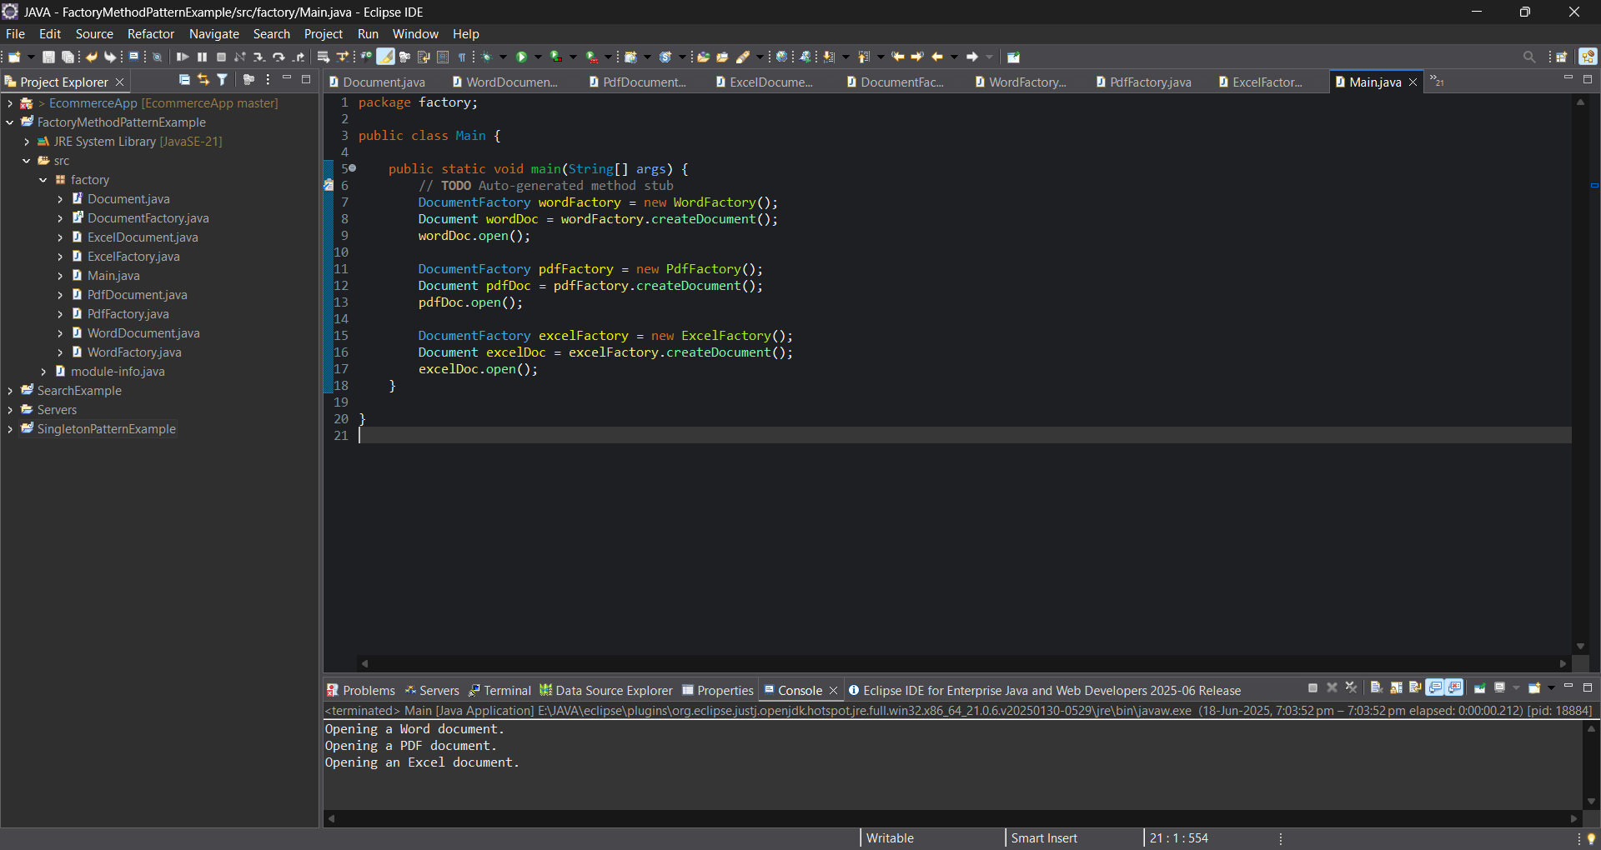

Exercise 3: E-commerce Platform Search Function
Product.java
package search;
public class Product
{
private int productId;
private String productName;
private String category;
public Product(int productId, String productName, String category)
{
this.productId = productId;
this.productName = productName;
this.category = category;
}
public int getProductId() {
return productId;
}
public String getProductName() {
return productName;
}
public String getCategory() {
return category;
}
}

SearchEngine.java
package search;
import java.util.Arrays;
public class SearchEngine
{
public static Product linearSearch(Product[] products, String name)
{
for (Product p : products)
{
if (p.getProductName().equalsIgnoreCase(name))
{
return p;
}
}
return null;
}
public static Product binarySearch(Product[] products, String name)
{
Arrays.sort(products, (a, b) -> a.getProductName().compareToIgnoreCase(b.getProductName()));
int low = 0;
int high = products.length - 1;
while (low <= high) {
int mid = (low + high) / 2;
int result = products[mid].getProductName().compareToIgnoreCase(name);
if (result == 0)
{
return products[mid];
}
else if (result < 0)
{
low = mid + 1;
}
else
{
high = mid - 1;
}
}
return null;
}
}
SearchTest.java
package search;
public class SearchTest
{
public static void main(String[] args) {
Product[] products = {
new Product(1, "Laptop", "Electronics"),
new Product(2, "Shoes", "Footwear"),
new Product(3, "Watch", "Accessories"),
new Product(4, "Mobile", "Electronics"),
new Product(5, "T-shirt", "Clothing")
};
String searchTerm = "Mobile";
System.out.println("Using Linear Search:");
Product result1 = SearchEngine.linearSearch(products, searchTerm);
printResult(result1);
System.out.println("\nUsing Binary Search:");
Product result2 = SearchEngine.binarySearch(products, searchTerm);
printResult(result2);
}
public static void printResult(Product product)
{
if (product != null)
{
System.out.println("Product Found: " + product.getProductName() + " in " + product.getCategory());
}
else
{
System.out.println("Product Not Found");
}
}
}

Output
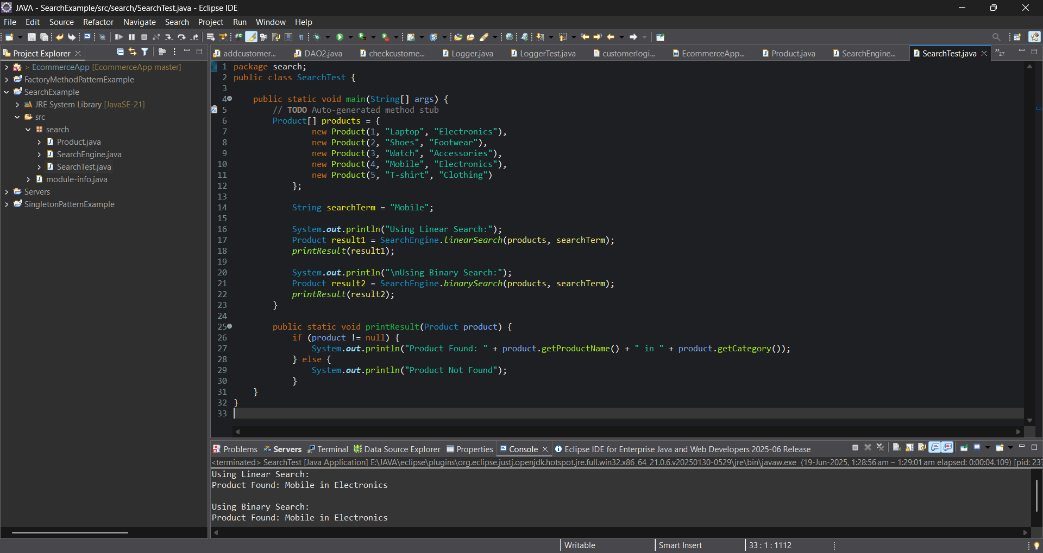

Exercise 4: Financial Forecasting

Forecast.java
package forecast;
public class Forecast
{
public static double calculateFutureValue(double currentValue, double growthRate, int years) {
if (years == 0)
{
return currentValue;
}
else
{
return calculateFutureValue(currentValue * (1 + growthRate), growthRate, years - 1);
}
}
public static void main(String[] args)
{
double initialValue = 10000.0;
double growthRate = 0.1;
int years = 5;
double futureValue = calculateFutureValue(initialValue, growthRate, years);
System.out.printf("The projected value after %d years is: ₹%.2f%n", years, futureValue);
}
}

Output
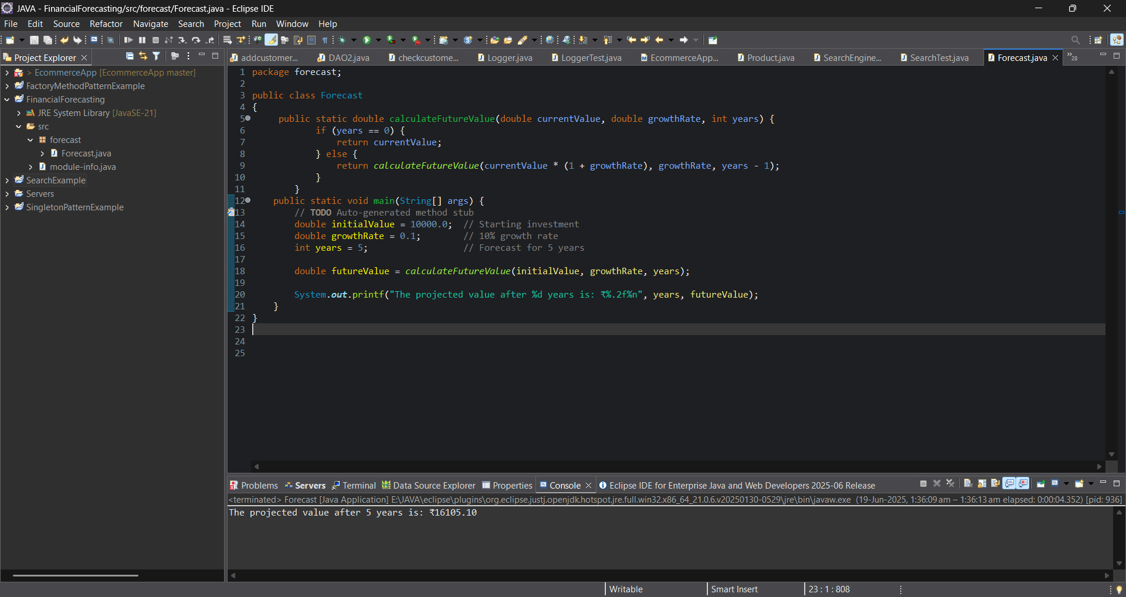
Exercise 5: Implementing the MVC Pattern

#Under model package
Student.java
package model;
public class Student {
private String id;
private String name;
private String grade;
public Student(String id, String name, String grade) {
this.id = id;
this.name = name;
this.grade = grade;
}
public String getId() {
return id;
}
public void setId(String id) {
this.id = id;
}
public String getName() {
return name;
}
public void setName(String name) {
this.name = name;
}
public String getGrade() {
return grade;
}
public void setGrade(String grade) {
this.grade = grade;
}
}

#Under view package
StudentView.java
package view;
import model.Student;
public class StudentView {
public void displayStudentDetails(Student student) {
System.out.println("---- Student Details ----");
System.out.println("ID : " + student.getId());
System.out.println("Name : " + student.getName());
System.out.println("Grade : " + student.getGrade());
System.out.println("-------------------------\n");
}
}

#Under Controller package
StudentController.java
package controller;
import model.Student;
import view.StudentView;
public class StudentController {
private Student model;
private StudentView view;
public StudentController(Student model, StudentView view) {
this.model = model;
this.view = view;
}
public String getStudentName() {
return model.getName();
}
public String getStudentId() {
return model.getId();
}
public String getStudentGrade() {
return model.getGrade();
}
public void setStudentName(String name) {
model.setName(name);
}
public void setStudentId(String id) {
model.setId(id);
}
public void setStudentGrade(String grade) {
model.setGrade(grade);
}
public void updateView() {
view.displayStudentDetails(model);
}
}

#Under Main package
Main.java
package main;
import model.Student;
import view.StudentView;
import controller.StudentController;
public class Main {
public static void main(String[] args) {
Student student = new Student("S101", "Alice", "A");
StudentView view = new StudentView();
StudentController controller = new StudentController(student, view);
controller.updateView();
controller.setStudentName("Alice Johnson");
controller.setStudentGrade("A+");
controller.updateView();
}
}

Output
